==== > **Launch SOAP UI by clicking on the logo from your local machine.**

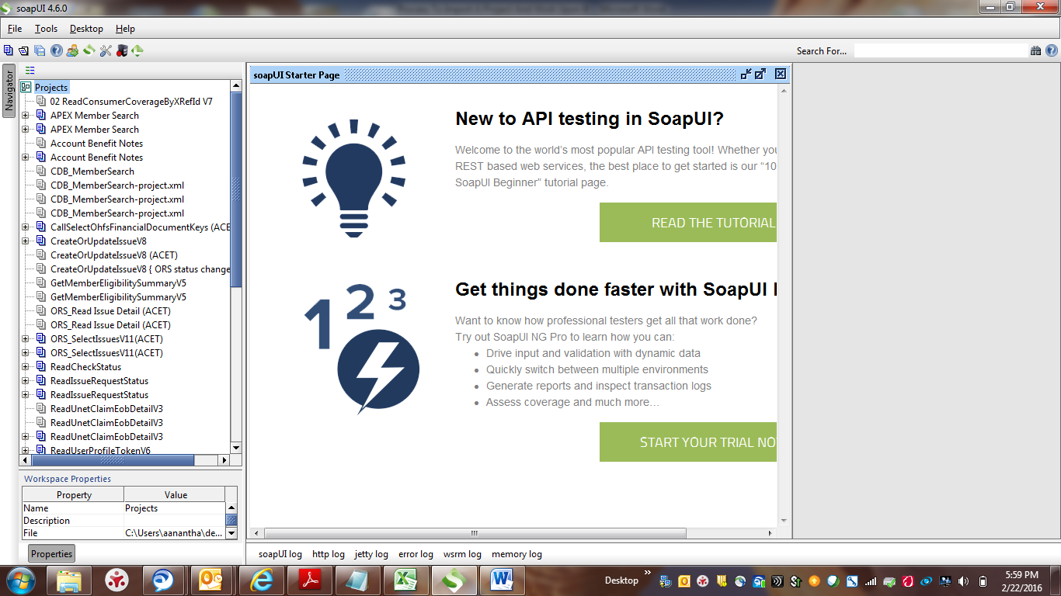

==== > **Click on File.**

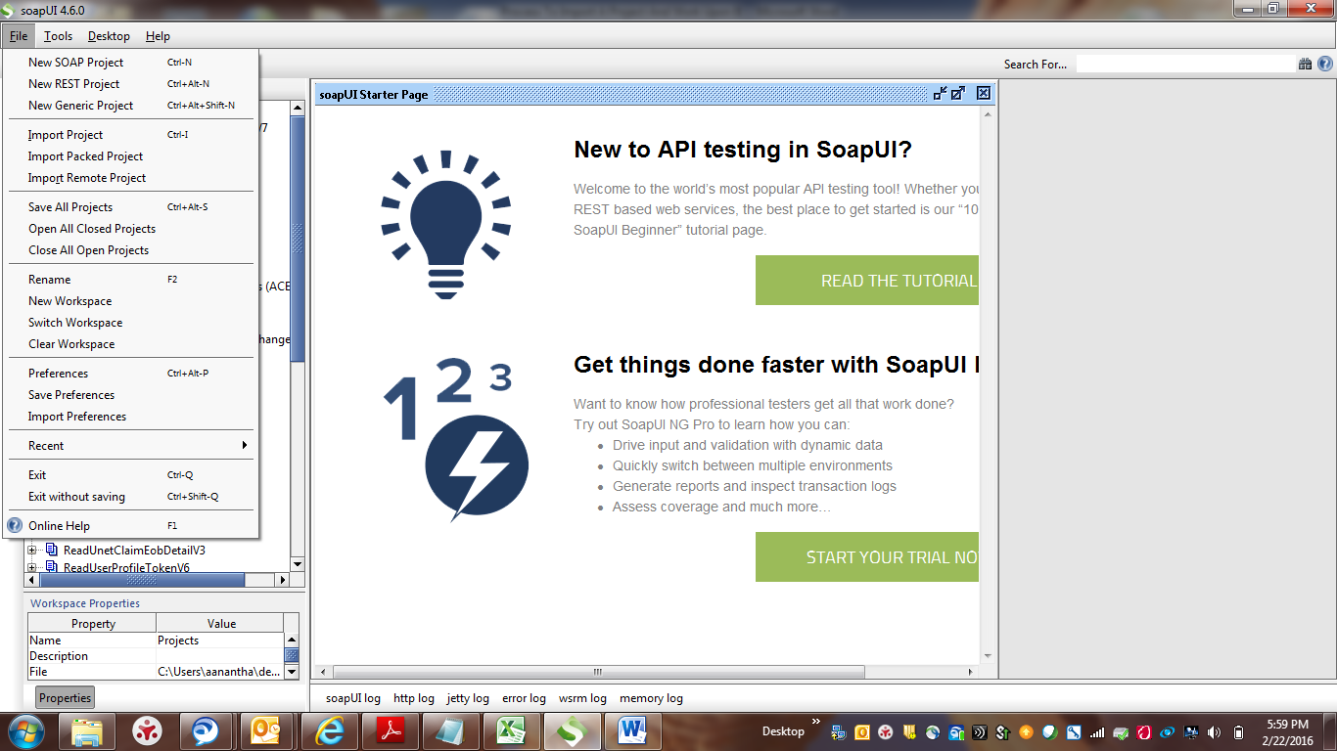

====> **Hover the mouse over New SOAP Project and click on it. System will display a new window with the name New SOAP Project.**

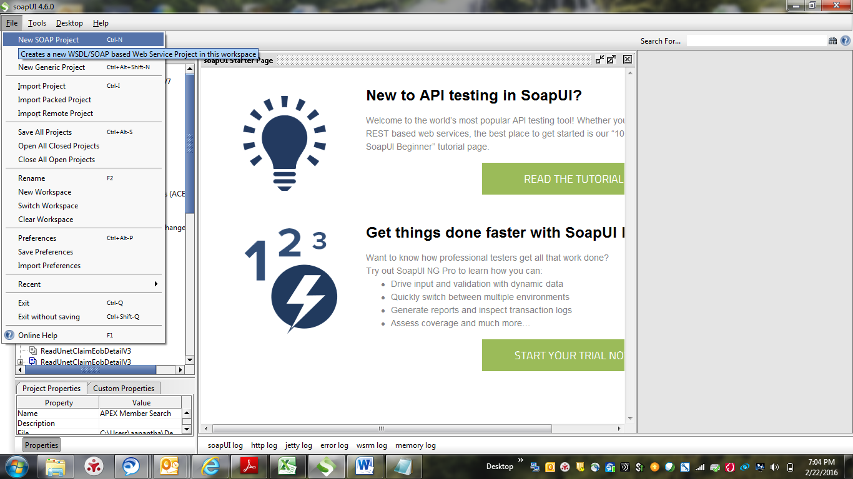

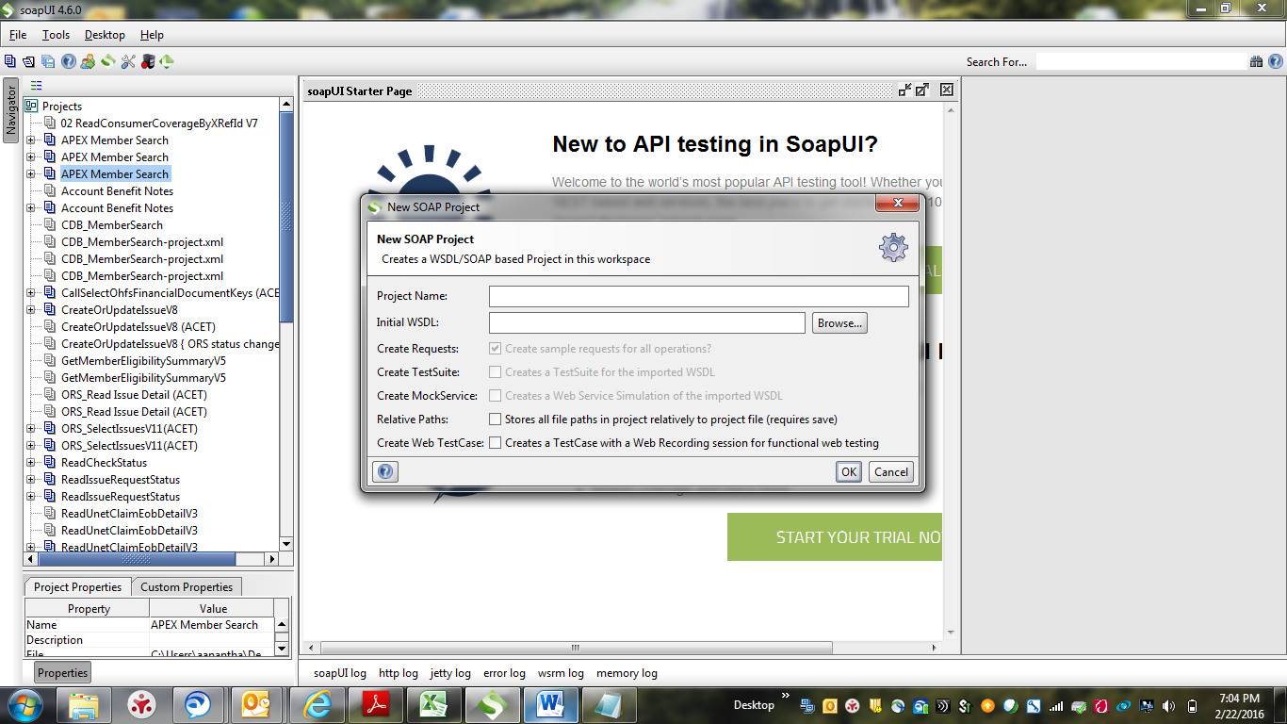

**==== > We can enter any name we want in the Project name field.**

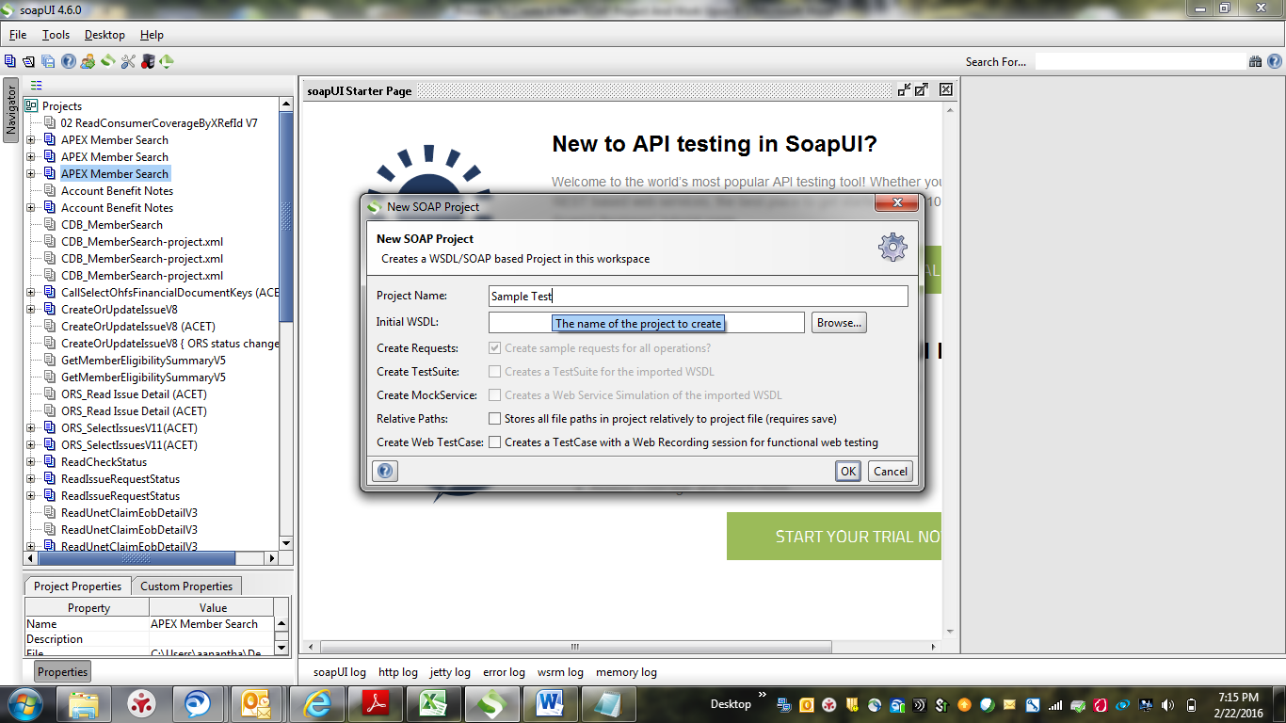

**==== > Enter the endpoint URL in the Initial WSDL field followed by “ ?wsdl “. And Click on OK. System will display the “ Sample Test “ project on the left panel.**

Sample end point URL :[**https://aesystestproxy-vm.uhc.com:33443/upm3/consumermember/SearchMembersV3**](https://aesystestproxy-vm.uhc.com:33443/upm3/consumermember/SearchMembersV3)

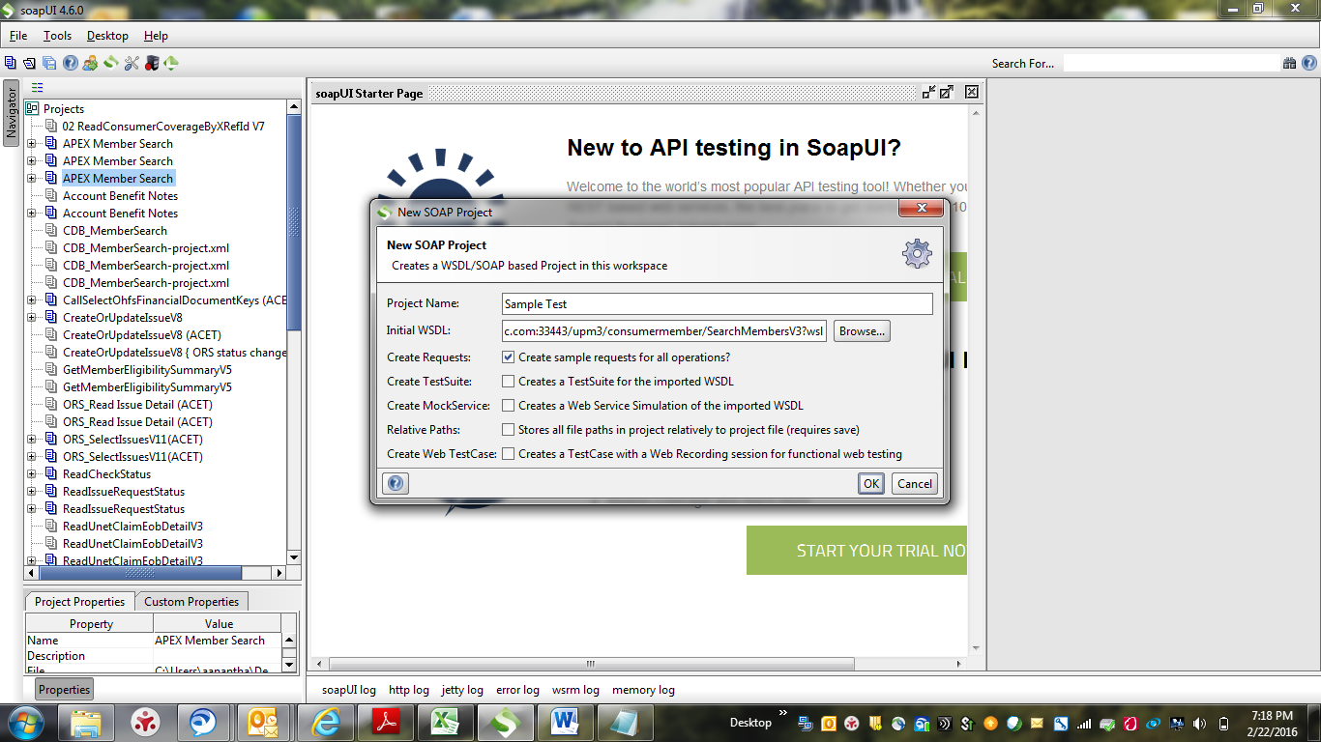

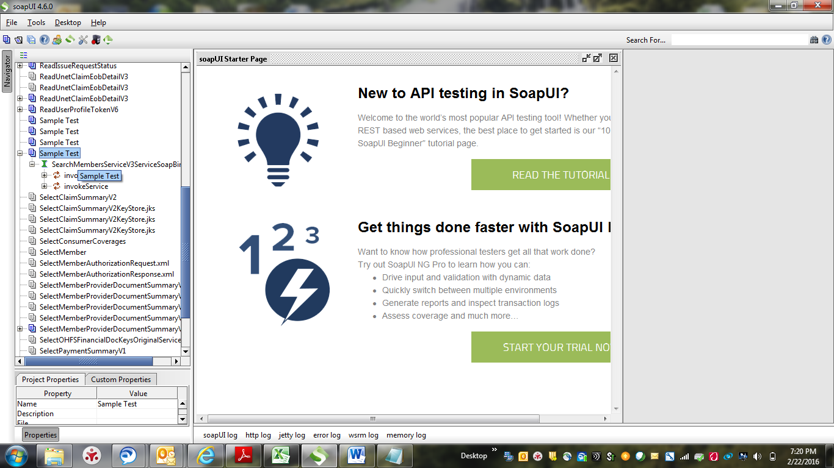

==== > **Expand the invokeService. System will display the Request. Double Click on the Request. System will display the new window with Request xml.**

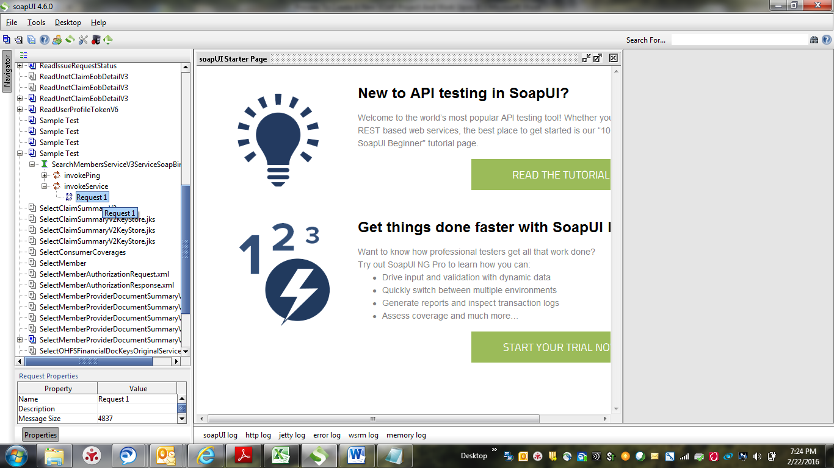

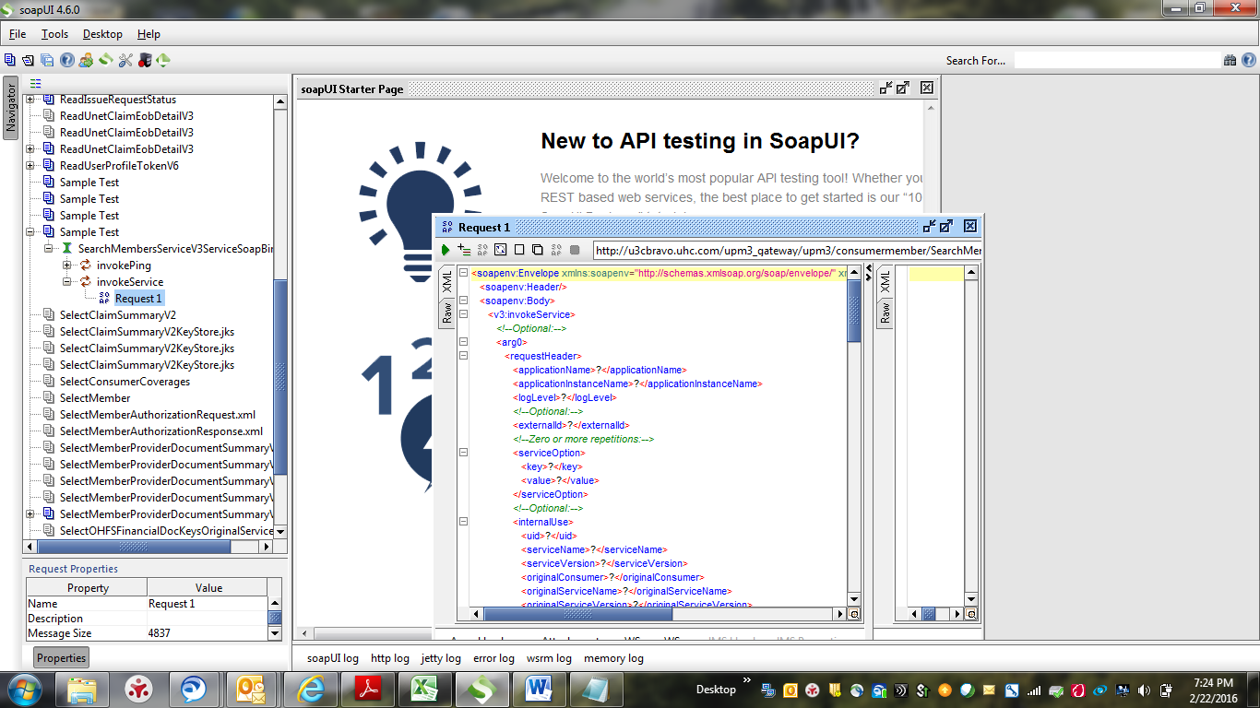

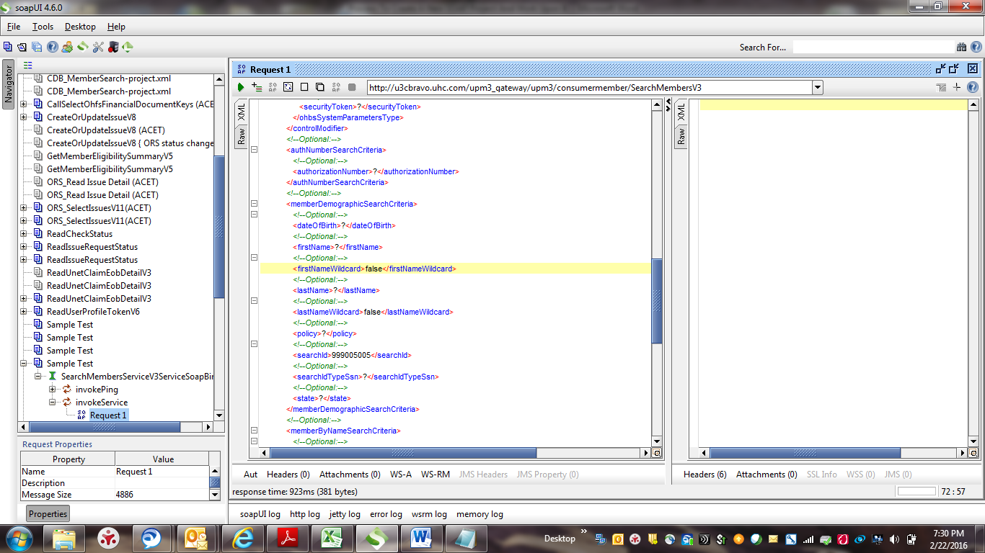

==== > **Enter the data for all the required request parameters in the request xml and click on Run button ( forward button) which is present at the top of the request xml window. Then system will display the response xml on the right side which is currently empty.**

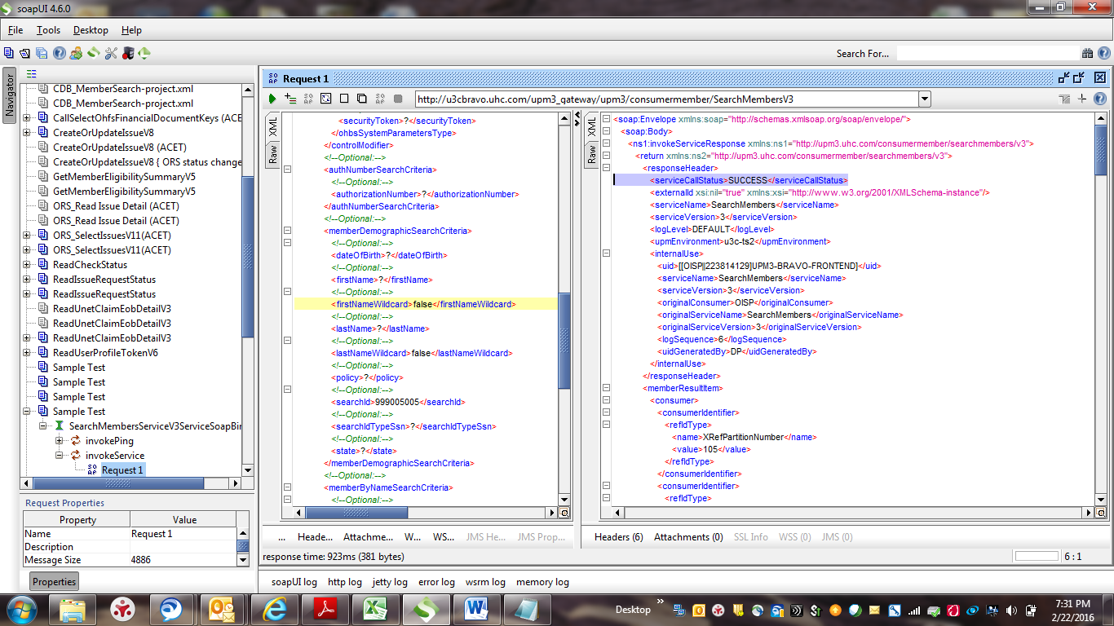

In the above screenshot, system is displaying the <serviceCallStatus>SUCCESS</serviceCallStatus> which means that the service is working perfectly.

==== > **A scroll bar will be present on the right side of the Response xml. Scroll down and view all the data returned in the Response xml and compare it with Application UI.**